**REPORT GENERATION FROM IBM COGNOS DASHBOARD**

As an user, I can get the detailed report on the particular visualization , I have visualized on the airstat dashboard.

Steps to obtain the report is explained through the following snapshots.

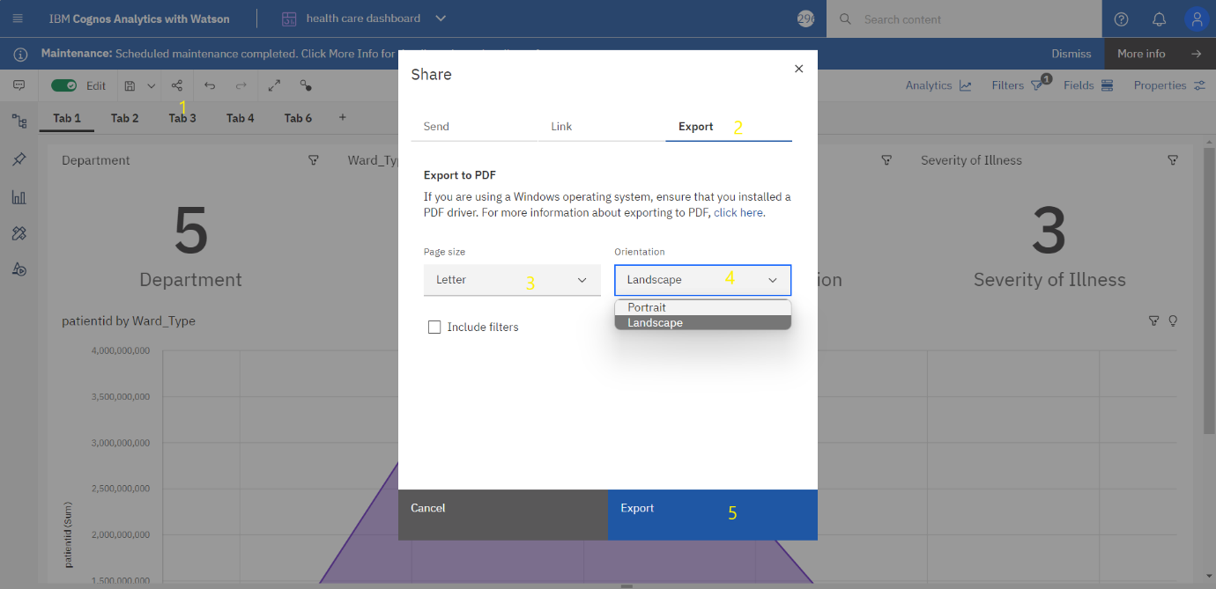

**STEPS :**

1. Click on the share button from the menu tab.
2. Click on the export button from the share dialog box.
3. Select the letter option from the page size dropdown.
4. Select the required orientation (Landscape) from the orientation dropdown.
5. Click on the export button from the dialog box.

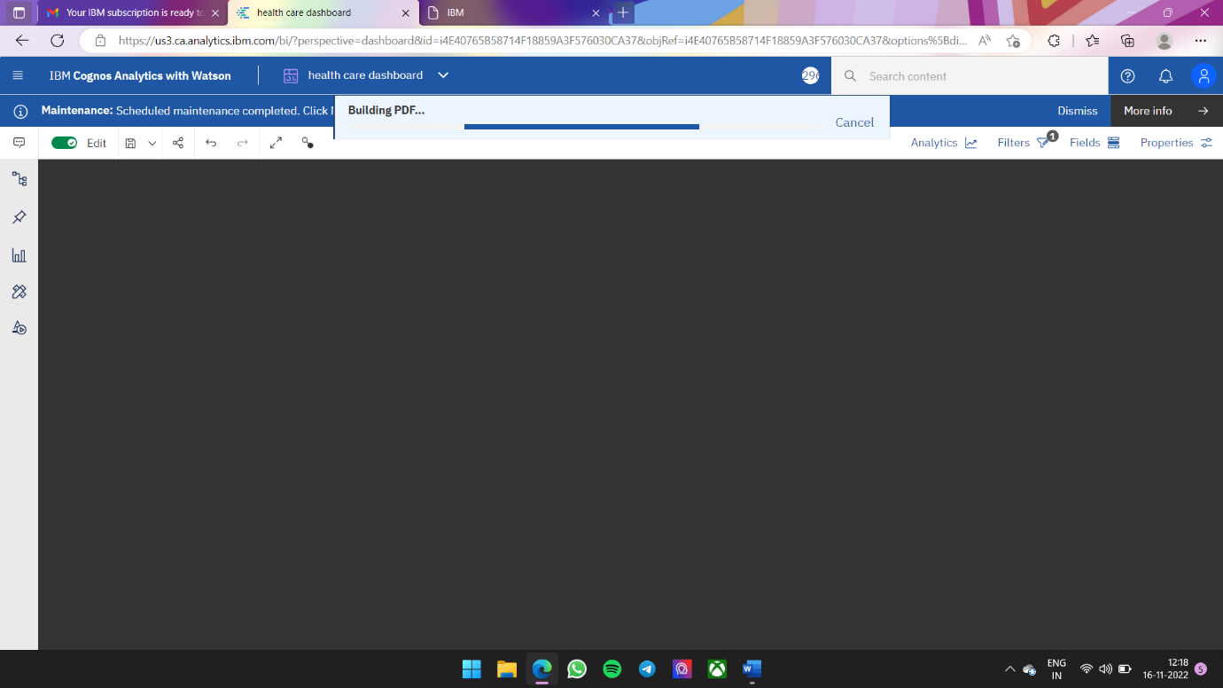

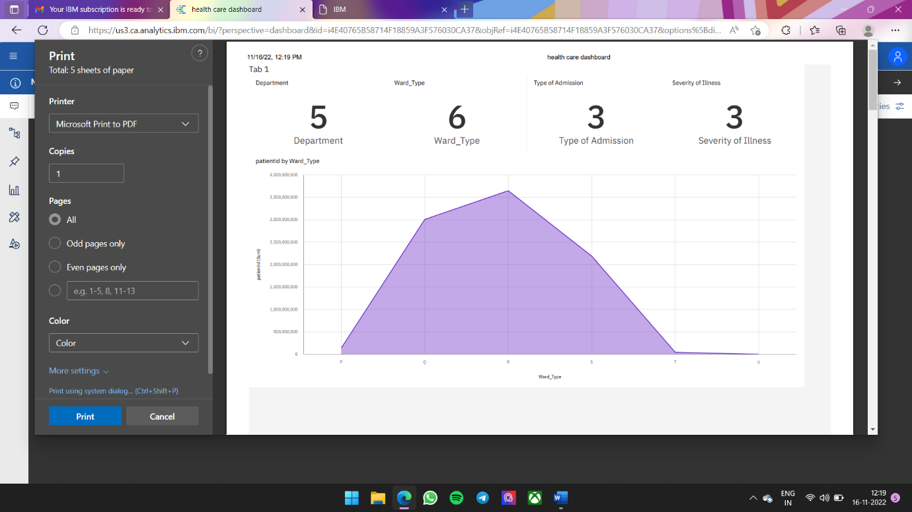

Select the required pdf format from the dialog box and click on the save button . And finally the report will be generated in the pdf format.

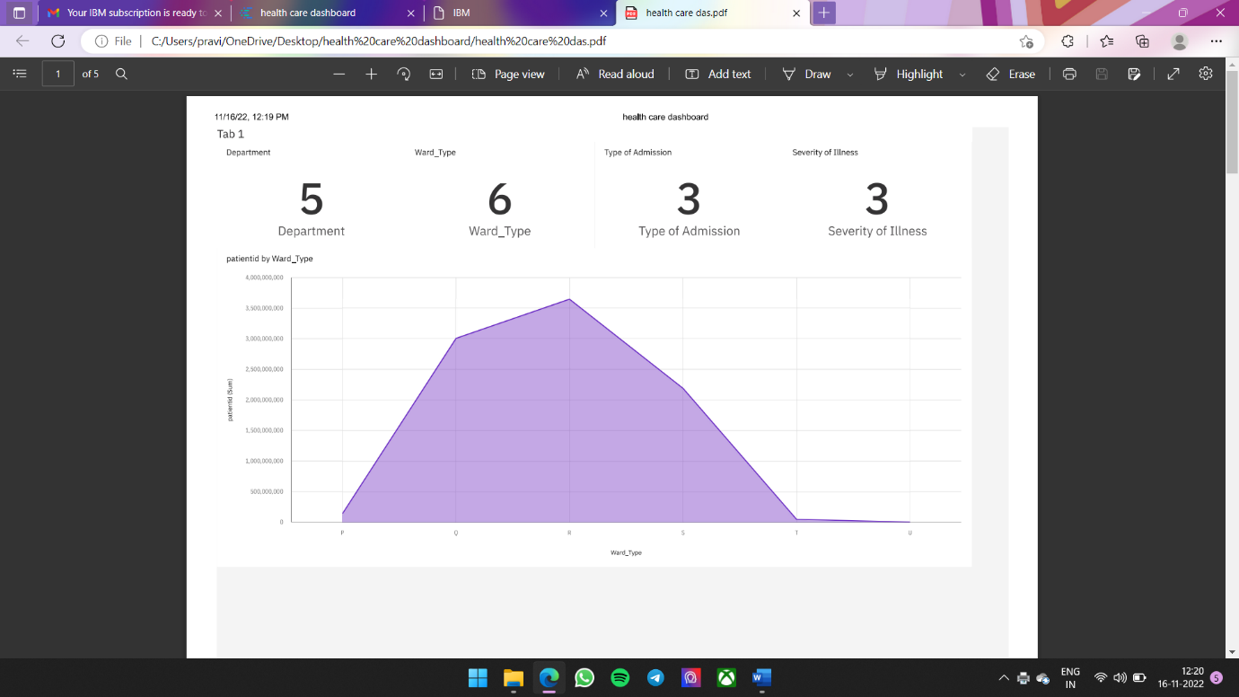

Sample report image

DASHBOARD LINK:

https://us3.ca.analytics.ibm.com/bi/?perspective=dashboard&pathRef=.my_folders%2Fhealth%2Bcare%2Bdashboard&action=view&mode=dashboard&subView=model0000018474d0411a_00000001